**Zomato Restaurants Analysis**

**Objective Questions**:

1. **What is the total no. of tables present in the data?**

2

1. **What is the total no. of attributes present in the data?**

21

1. **How many categorical columns are there in the data? [Search about categorical and continuous data, and try to answer this question]**

There are 17 categorical columns in the data :

1. RestaurantName
2. CountryCode
3. City
4. Address
5. Locality
6. LocalityVerbose
7. Cuisines
8. Currency
9. Has_Table_booking
10. Has_Online_delivery
11. Is_delivering_now
12. Switch_to_order_menu
13. Price_range
14. Votes
15. Rating
16. Datekey_Opening
17. Country Name
18. **The data consists of some inconsistent and missing values so ensure that the data used for further analysis is cleaned.**

* Checked for the duplicate rows.
* Removed the rows that consists of (0,0) in Latitude and Longitude.
* Converted the date column from text format to the date format.
* Converted all currency to INR which is standard and easy to compare.
* Applied formatting to remove special characters, extra spaces, and ensure proper casing.
* Deleted the extra columns.

1. **Using the LookUp functions, fill up the countries in the original data using the country code.**

=VLOOKUP([@CountryCode],'country description'!A:B,2,0)

1. **Create a table to represent the number of restaurants opened in each country.**

| **Country** | **Count of RestaurantID** |
| --- | --- |
| **Australia** | **24** |
| **Brazil** | **60** |
| **Canada** | **4** |
| **India** | **8147** |
| **Indonesia** | **20** |
| **New Zealand** | **39** |
| **Philippines** | **22** |
| **Qatar** | **20** |
| **Singapore** | **20** |
| **South Africa** | **60** |
| **Sri Lanka** | **19** |
| **Turkey** | **34** |
| **United Arab Emirates** | **60** |
| **United Kingdom** | **80** |
| **United States of America** | **434** |
| **Grand Total** | **9043** |

1. **Also, the management wants to look at the number of restaurants opened each year, so provide them with something here.**

| **Year** | **Count of RestaurantID** |
| --- | --- |
| **2010** | **1019** |
| **2011** | **1040** |
| **2012** | **975** |
| **2013** | **999** |
| **2014** | **1009** |
| **2015** | **967** |
| **2016** | **964** |
| **2017** | **1022** |
| **2018** | **1048** |
| **Grand Total** | **9043** |

1. **What is the total number of restaurants in India in the price range of 4?**

=COUNTIFS('Raw Data'!D:D,"India",'Raw Data'!Q:Q,4)

=388

1. **What is the average number of voters for the restaurants in each country according to the data?**

| **Country** | **Average of Votes** |
| --- | --- |
| **Australia** | **111.42** |
| **Brazil** | **19.62** |
| **Canada** | **103.00** |
| **India** | **143.91** |
| **Indonesia** | **803.10** |
| **New Zealand** | **248.46** |
| **Philippines** | **407.41** |
| **Qatar** | **163.80** |
| **Singapore** | **31.90** |
| **South Africa** | **315.17** |
| **Sri Lanka** | **145.16** |
| **Turkey** | **431.47** |
| **United Arab Emirates** | **493.52** |
| **United Kingdom** | **205.49** |
| **United States of America** | **428.22** |
| **Grand Total** | **164.0552914** |

1. **Calculate the average rating for all the restaurants that have price_range < 4 and provide online delivery. Use only the “IF” function, Logical Operators, and Aggregation functions to solve this problem. [Note: Don’t use Conditional aggregation in this question.]**

=ARRAYFORMULA(AVERAGE(IF(('Raw Data'!$Q:$Q < 4) * ('Raw Data'!$N:$N = "Yes"), 'Raw Data'!$T:$T)

=**3.2730**

1. **Using Conditional formatting highlight the rows of restaurants that are located in the countries or cities that you’ve suggested to the management for opening new restaurants.**

Used Helper column and then applied conditional formatting,

=IF(OR($D2="New Zealand", $D2="Philippines", $D2="Sri Lanka", $D2="Turkey", $D2="Indonesia"), 1, 0)

Formula for conditional formatting

=$X2=1

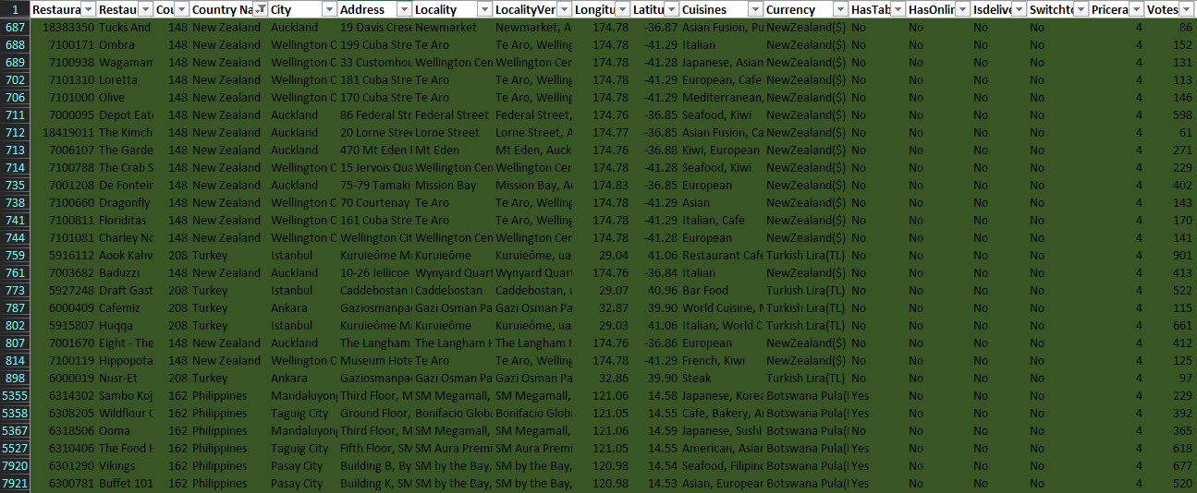

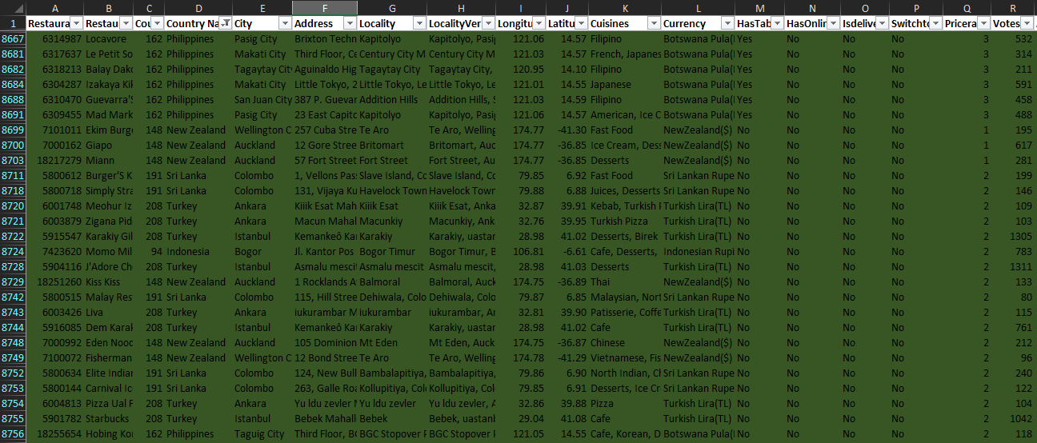

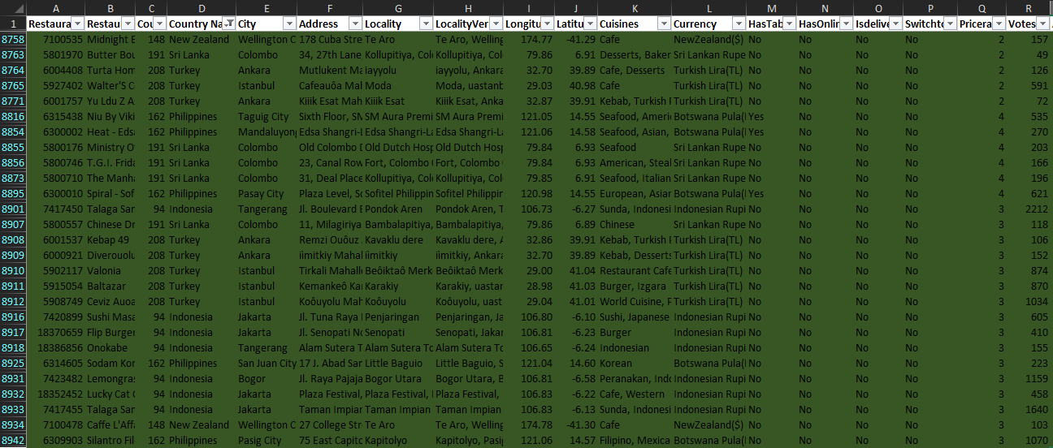

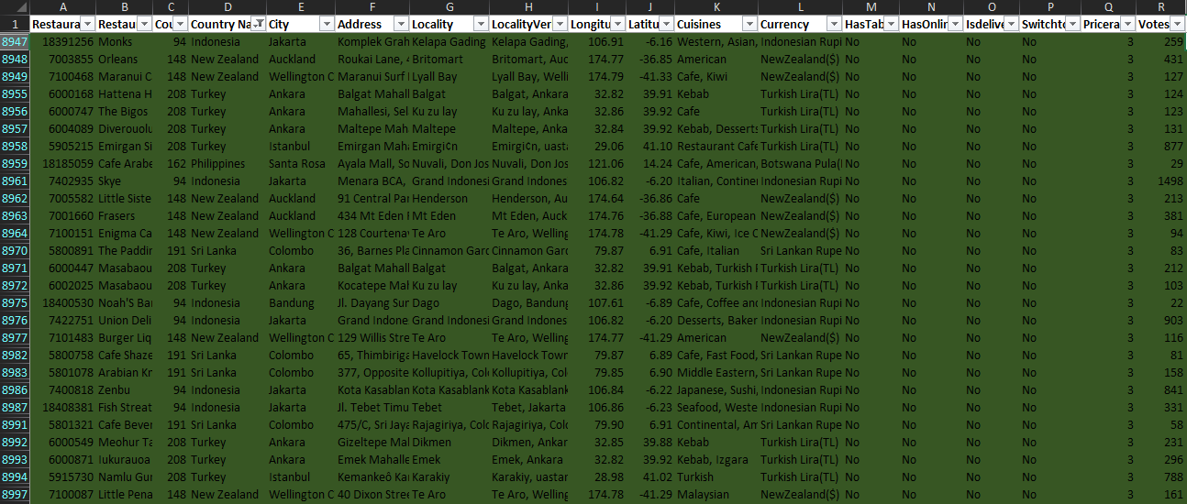

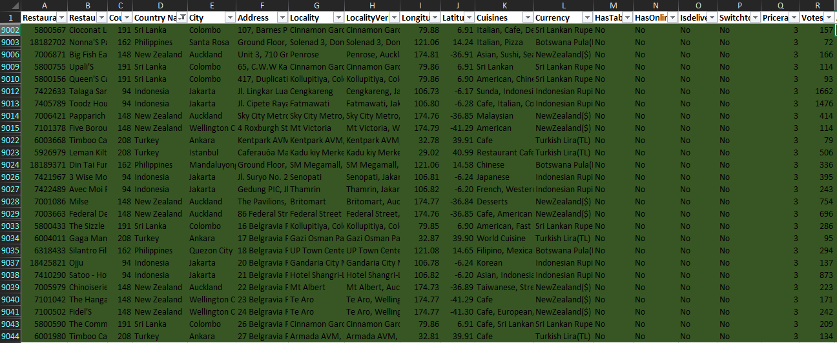

1. **Create a new customized price column that consists of the abbreviation/symbol of the currency along with the Average_cost_for_two value. [Use string operations to do this task]**

=CONCATENATE((RIGHT(L2,len(L2)-FIND("(",L2)+1)),S2)

1. **How can you create an array formula in Excel or Google Sheets to count the number of restaurants listed that do not offer online delivery, are in the lowest price range, and have an average cost for two people less than or equal to 250 Indian Rupees?**

=ARRAYFORMULA(SUM(('RawData'!N2:N="No")*('RawData'!Q2:Q=1)*('Raw Data'!S2:S<=250)))

**=1676**

**Subjective Question:**

1. **Suggest a few countries where the team can open newer restaurants with lesser competition. Which visualization/technique will you use here to justify the suggestions?**

| **Country** | **Count of RestaurantID** | **Average of Votes** | **Average of Rating** |
| --- | --- | --- | --- |
| **Australia** | **24** | **111.42** | **3.66** |
| **Brazil** | **60** | **19.62** | **3.85** |
| **Canada** | **4** | **103.00** | **3.58** |
| **India** | **8147** | **143.91** | **2.81** |
| **Indonesia** | **20** | **803.10** | **4.34** |
| **New Zealand** | **39** | **248.46** | **4.27** |
| **Philippines** | **22** | **407.41** | **4.47** |
| **Qatar** | **20** | **163.80** | **4.06** |
| **Singapore** | **20** | **31.90** | **3.58** |
| **South Africa** | **60** | **315.17** | **4.21** |
| **Sri Lanka** | **19** | **145.16** | **3.85** |
| **Turkey** | **34** | **431.47** | **4.30** |
| **United Arab Emirates** | **60** | **493.52** | **4.23** |
| **United Kingdom** | **80** | **205.49** | **4.10** |
| **United States of America** | **434** | **428.22** | **4.01** |
| **Grand Total** | **9043** | **164.0552914** | **2.935884109** |

1.Number of Restaurant vs. Country Name(Excluding India)

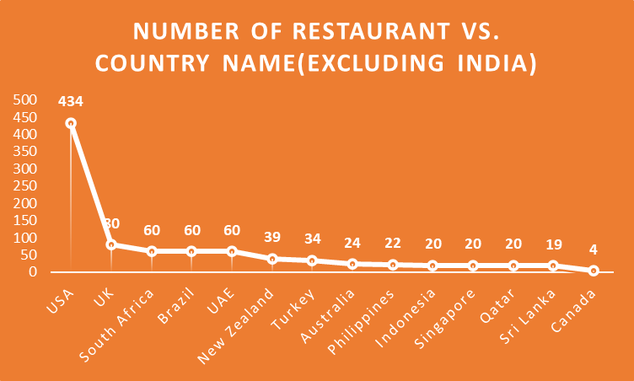

Expanding in low-competition countries will help in establishing a strong market presence with fewer direct competitors.

2. Average of Rating vs. Number of Restaurant

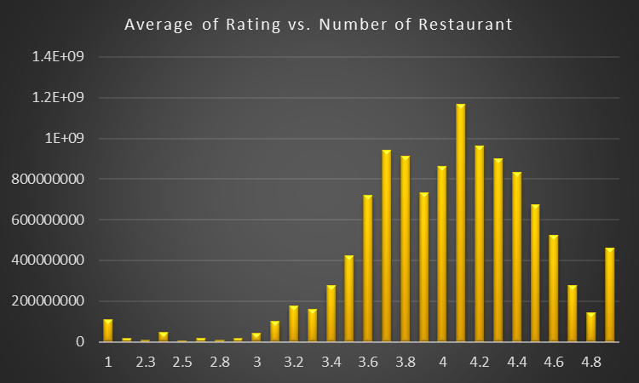

Countries with high ratings & low competition are the best expansion opportunities.

**Best Countries to Expand Into:**

Expand in countries with fewer restaurants & high customer ratings,

* Philippines & Indonesia → Best opportunities due to high ratings and low competition.
* Turkey & New Zealand → High ratings and slightly more competition.
* Sri Lanka → Lowest competition but moderate customer satisfaction.

**Recommendations :**

Prioritize Philippines, Indonesia, and Turkey, followed by New Zealand and Sri Lanka for gradual expansion.

1. **Come up with the names of States and cities in the suggested countries suitable for opening restaurants.**

| **City** | **Count of RestaurantID** | **Average of Votes** | **Average of Rating** |
| --- | --- | --- | --- |
| **Ankara** | **20** | **131.35** | **4.305** |
| **Auckland** | **19** | **356** | **4.289473684** |
| **Colombo** | **19** | **145.1578947** | **3.852631579** |
| **Jakarta** | **15** | **782.0666667** | **4.42** |
| **Mandaluyong City** | **4** | **300** | **4.625** |
| **Pasay City** | **3** | **606** | **4.366666667** |
| **Pasig City** | **3** | **696.6666667** | **4.633333333** |
| **Taguig City** | **4** | **415.75** | **4.525** |
| **Wellington City** | **20** | **146.3** | **4.25** |
| **Istanbul** | **14** | **860.2142857** | **4.292857143** |
| **Grand Total** | **121** | **377.0247934** | **4.262809917** |

1.Number of Restaurants vs. City

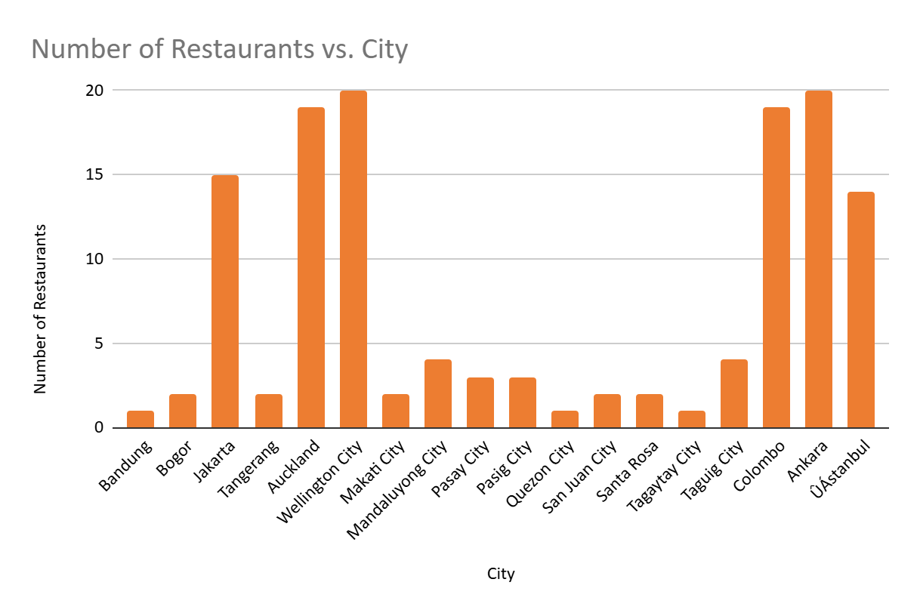

Cities with fewer restaurants but high ratings are great for expansion.

2.Average of Rating vs. City

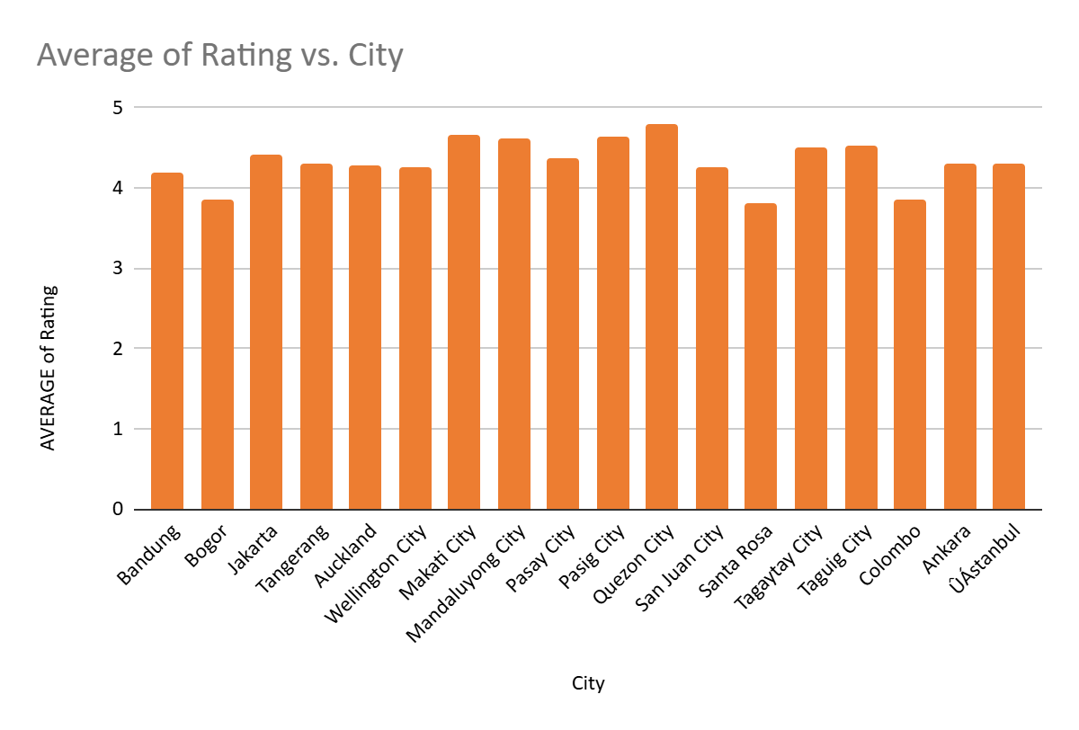

Cities with high ratings indicate strong customer satisfaction

**Key Insights :**

From both Charts,

1️ Indonesia – Jakarta & Tangerang  
 High demand with strong ratings, moderate competition.

2️ New Zealand – Auckland & Wellington City  
 Growing market with good customer satisfaction.

3️ Philippines – Quezon City & Makati City  
 Best opportunity with high ratings and low competition.

4️ Sri Lanka – Colombo  
 Lowest competition but needs quality improvement.

5️ Turkey – Ankara & Istanbul  
 Well-established food scene with moderate competition.

1. **According to the countries you suggested, what is the current quality regarding ratings for restaurants that are open there?**

| **Country** | **Average of Rating** |
| --- | --- |
| **Australia** | **3.66** |
| **Brazil** | **3.85** |
| **Canada** | **3.58** |
| **India** | **2.81** |
| **Indonesia** | **4.34** |
| **New Zealand** | **4.27** |
| **Philippines** | **4.47** |
| **Qatar** | **4.06** |
| **Singapore** | **3.58** |
| **South Africa** | **4.21** |
| **Sri Lanka** | **3.85** |
| **Turkey** | **4.30** |
| **United Arab Emirates** | **4.23** |
| **United Kingdom** | **4.10** |
| **United States of America** | **4.01** |
| **Grand Total** | **2.94** |

Average of rating vs. Country Name

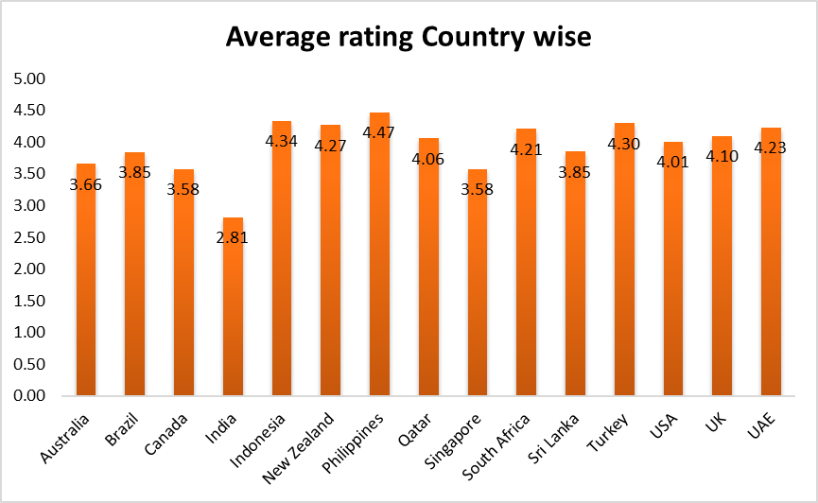

**Key Insights:**

Philippines (4.47) – Best opportunity with high ratings and low competition.

Indonesia (4.34) – Strong market, low competition, and quality restaurants.

Turkey (4.3) – Well-established food scene, moderate competition, but high demand.

New Zealand (4.27) – Good customer satisfaction, moderate competition, and growth potential.

Sri Lanka (3.85) – Lowest competition, but scope for improving quality and service.

1. **Also, what is the current expenditure on food in the suggested countries, so we can keep our financial expenditure in control?**

| **Country** | **Average of AverageCostfortwo** |
| --- | --- |
| **Australia** | **1998.92** |
| **Brazil** | **2235.47** |
| **Canada** | **3008.75** |
| **India** | **605.23** |
| **Indonesia** | **1541.81** |
| **New Zealand** | **3343.66** |
| **Philippines** | **9695.14** |
| **Qatar** | **5099.89** |
| **Singapore** | **12927.25** |
| **South Africa** | **1896.12** |
| **Sri Lanka** | **660.94** |
| **Turkey** | **194.44** |
| **United Arab Emirates** | **3760.57** |
| **United Kingdom** | **4998.25** |
| **United States of America** | **2170.62** |
| **Grand Total** | **836.06** |

Average Cost of two Country-wise (INR)

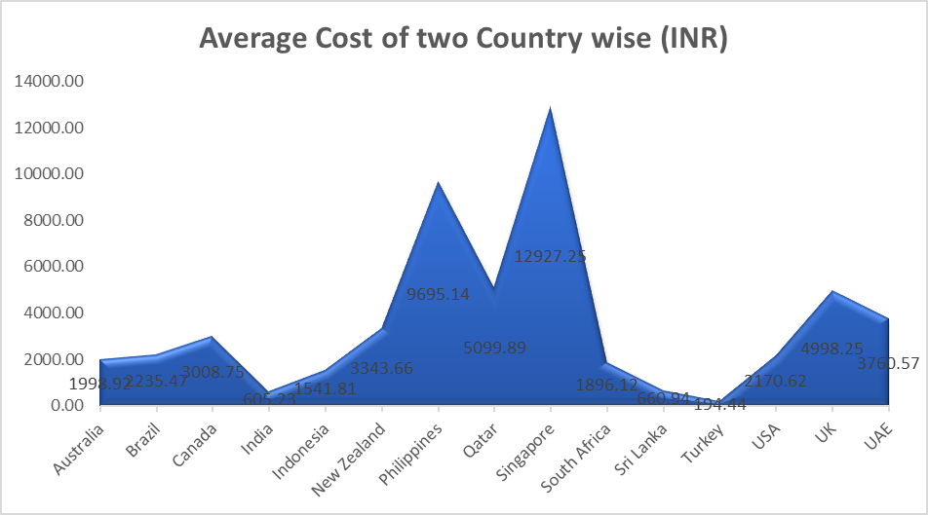

#### **Key Insights:**

* **Most Affordable Countries**: Turkey (194) and Sri Lanka (661) offer the lowest average dining costs.
* **Moderate Spending**: Indonesia (1,542) and New Zealand (3,344) require careful budgeting.
* **Highest Expenditure**: The Philippines (9,695) has the highest dining costs, requiring strict financial planning.
* **Significant Cost Variance**: The cost difference between the most affordable (Turkey) and the highest (Philippines) is nearly **50x**, impacting budget allocation.
* **Potential Cost Savings**: Prioritizing expansion in Sri Lanka and Turkey can reduce operational costs and improve profitability.

#### **Recommendations:**

* Budget Allocation: Set aside more money for food costs in New Zealand and the Philippines.
* Cost-Effective Expansion: For an affordable market entry strategy, concentrate on Sri Lanka and Turkey.
* Pricing Strategy: To preserve profitability, modify pricing models in high-cost areas.

1. **Come up with the names of restaurants from the recommended states that are our biggest competitors and also those that are rated in the lower brackets, i.e. 1-2 or 2-3.**

| **Row Labels** | **Average of Rating** |
| --- | --- |
| **Ankara** | **4.305** |
| **Cafemiz** | **4.4** |
| **Gaga Manjero** | **4.9** |
| **Kebap 49** | **4.3** |
| **Liva** | **3.4** |
| **Nusr-Et** | **4.1** |
| **The Bigos** | **3.8** |
| **Timboo Cafe** | **4.2** |
| **Turta Home Cafe** | **4.3** |
| **Zigana Pide** | **4.3** |
| **Meohur Izielik Aspava** | **4.6** |
| **Pizza Ual Forno** | **4.7** |
| **Yu Ldu Z Aspava** | **4.4** |
| **Diverouolu** | **4.3** |
| **Hattena Hatay Sofrasu** | **4.6** |
| **Masabaou Kebapiu Su** | **4.2** |
| **Masabaou** | **4.2** |
| **Meohur Tavacu Recep Usta** | **4.5** |
| **Iukurauoa Sofrasu** | **4.4** |
| **Auckland** | **4.28** |
| **Baduzzi** | **4.6** |
| **Big Fish Eatery** | **4.5** |
| **Chinoiserie** | **4.4** |
| **De Fontein Belgian Beer Cafe** | **2.3** |
| **Depot Eatery And Oyster Bar** | **4.8** |
| **Eight - The Langham Hotel** | **4.7** |
| **Federal Delicatessen** | **4.6** |
| **Frasers** | **4** |
| **Giapo** | **4.7** |
| **Kiss Kiss** | **4.3** |
| **Little Sister Cafe** | **4.5** |
| **Miann** | **4.9** |
| **Milse** | **4.9** |
| **Orleans** | **4.1** |
| **Papparich** | **4** |
| **The Garden Shed** | **4.2** |
| **The Kimchi Project** | **4.2** |
| **Tucks And Bao** | **3.5** |
| **Eden Noodles Café** | **4.3** |
| **Bandung** | **4.2** |
| **Noah'S Barn Coffeenery** | **4.2** |
| **Bogor** | **3.85** |
| **Lemongrass** | **4** |
| **Momo Milk** | **3.7** |
| **Colombo** | **3.85** |
| **Arabian Knights** | **4.2** |
| **Burger'S King** | **4.1** |
| **Butter Boutique** | **4.2** |
| **Cafe Beverly** | **4.1** |
| **Cafe Shaze** | **3.8** |
| **Carnival Ice Cream** | **4.1** |
| **Chinese Dragon Cafe** | **3.4** |
| **Cioconat Lounge** | **3.7** |
| **Elite Indian Restaurant** | **2.4** |
| **Malay Restaurant** | **3.5** |
| **Ministry Of Crab** | **4.9** |
| **Queen'S Cafe** | **2.5** |
| **Simply Strawberries By Jagro** | **4.5** |
| **T.G.I. Friday'S** | **4** |
| **The Commons** | **4** |
| **The Manhattan Fish Market** | **4** |
| **The Paddington** | **3.6** |
| **The Sizzle** | **4.2** |
| **Upali'S** | **4** |
| **Jakarta** | **4.42** |
| **3 Wise Monkeys** | **4.2** |
| **Avec Moi Restaurant And Bar** | **4.3** |
| **Fish Streat** | **4** |
| **Flip Burger** | **4.4** |
| **Lucky Cat Coffee & Kitchen** | **4.3** |
| **Monks** | **4.2** |
| **Ojju** | **3.9** |
| **Satoo - Hotel Shangri-La** | **4.6** |
| **Skye** | **4.1** |
| **Sushi Masa** | **4.9** |
| **Talaga Sampireun** | **4.9** |
| **Toodz House** | **4.6** |
| **Union Deli** | **4.6** |
| **Zenbu** | **4.4** |
| **Makati City** | **4.65** |
| **Izakaya Kikufuji** | **4.5** |
| **Le Petit Souffle** | **4.8** |
| **Mandaluyong City** | **4.6** |
| **Din Tai Fung** | **4.4** |
| **Heat - Edsa Shangri-La** | **4.4** |
| **Ooma** | **4.9** |
| **Sambo Kojin** | **4.8** |
| **Pasay City** | **4.36** |
| **Buffet 101** | **4** |
| **Spiral - Sofitel Philippine Plaza Manila** | **4.9** |
| **Vikings** | **4.2** |
| **Pasig City** | **4.63** |
| **Locavore** | **4.8** |
| **Mad Mark'S Creamery & Good Eats** | **4.2** |
| **Silantro Fil-Mex** | **4.9** |
| **Quezon City** | **4.8** |
| **Silantro Fil-Mex** | **4.8** |
| **San Juan City** | **4.25** |
| **Guevarra'S** | **4.2** |
| **Sodam Korean Restaurant** | **4.3** |
| **Santa Rosa** | **3.8** |
| **Cafe Arabelle** | **3.6** |
| **Nonna'S Pasta & Pizzeria** | **4** |
| **Tagaytay City** | **4.5** |
| **Balay Dako** | **4.5** |
| **Taguig City** | **4.5** |
| **Hobing Korean Dessert Cafe** | **4.5** |
| **Niu By Vikings** | **4.7** |
| **The Food Hall By Todd English** | **4.5** |
| **Wildflour Cafe + Bakery** | **4.4** |
| **Tangerang** | **4.3** |
| **Onokabe** | **3.7** |
| **Talaga Sampireun** | **4.9** |
| **Wellington City** | **4.25** |
| **Burger Liquor** | **4.1** |
| **Caffe L'Affare** | **4.1** |
| **Charley Noble Eatery & Bar** | **4.3** |
| **Dragonfly** | **4.3** |
| **Ekim Burgers** | **4.5** |
| **Enigma Cafe** | **4** |
| **Fidel'S** | **4.4** |
| **Fisherman'S Plate** | **4.3** |
| **Five Boroughs** | **4.1** |
| **Floriditas** | **4.2** |
| **Hippopotamus - Museum Hotel** | **4.4** |
| **Little Penang** | **4.4** |
| **Loretta** | **4.2** |
| **Maranui Cafe** | **4.3** |
| **Midnight Espresso** | **4.3** |
| **Olive** | **4.2** |
| **Ombra** | **4.5** |
| **The Crab Shack** | **4.1** |
| **The Hangar** | **4.6** |
| **Wagamama** | **3.7** |
| **Istanbul** | **4.29** |
| **Baltazar** | **4.3** |
| **Draft Gastro Pub** | **4.9** |
| **Huqqa** | **3.7** |
| **J'Adore Chocolatier** | **4.7** |
| **Starbucks** | **4.9** |
| **Valonia** | **4.2** |
| **Walter'S Coffee Roastery** | **4** |
| **Aook Kahve** | **4** |
| **Karakiy Gilliouolu** | **4.7** |
| **Dem Karakiy** | **4.5** |
| **Ceviz Auoacu** | **4.2** |
| **Emirgan Sitio** | **4.2** |
| **Namlu Gurme** | **4.1** |
| **Leman Kiltir** | **3.7** |
| **Grand Total** | **4.26119403** |

**Key Insights :**

#### **1. Highly Rated Competitors & Their Impact**

* Cities like Auckland, Jakarta, and Istanbul have multiple top-rated restaurants (above 4.5 stars).
* These restaurants are strong competitors, indicating high customer satisfaction and a strong market presence.
* Cities with highly competitive markets: Auckland, Jakarta, and Istanbul.
* Strategic focus: Competing in these cities requires unique offerings, exceptional customer service, and strong branding.

**Recommendation:**

* Analyze the strengths of these top competitors (menu, pricing, service quality, online presence).
* Consider partnerships, promotions, or innovative offerings to differentiate from these well-established brands.

#### 

#### **2. Low-Rated Competitors & Market Gaps**

* Some cities like Colombo, Bogor, and Santa Rosa have restaurants with low ratings (below 3.5).
* This suggests potential gaps in food quality, service, or pricing.
* Cities with weak competitors: Colombo, Bogor, Santa Rosa, and some parts of Istanbul.

**Recommendation:**

* Opportunity for expansion: These cities could be ideal for introducing high-quality offerings to attract dissatisfied customers.
* Focus on delivering better customer service, innovative menu options, and effective marketing to capture market share.

1. **Which cuisines should we focus on in the newer restaurants to get better feedback? Does the choice of cuisines affect the restaurant ratings?**

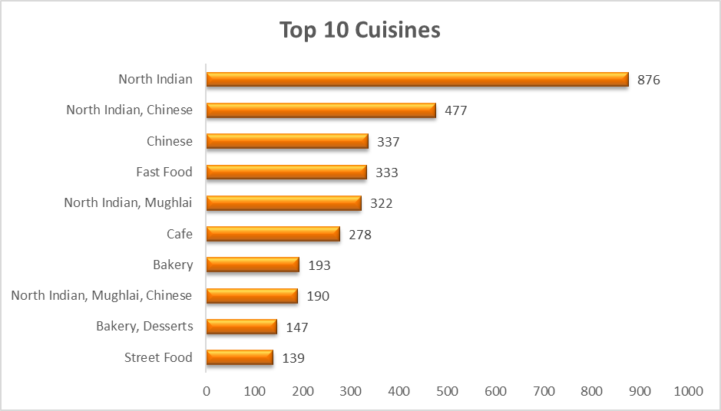

Top 10 Cuisines

| **Cuisines** | **Average of Rating** | **Average of AverageCostfortwo** |
| --- | --- | --- |
| **American** | **4.1** | **2855.53** |
| **American, Asian, Italian, Seafood** | **4.5** | **10860.75** |
| **American, Chinese, North Indian** | **2.5** | **564.40** |
| **American, Fast Food, Steak, Beverages** | **4.2** | **846.60** |
| **American, Ice Cream, Desserts** | **4.2** | **5430.38** |
| **American, Steak** | **4** | **1128.80** |
| **Asian** | **4.3** | **4759.22** |
| **Asian Fusion, Cafe** | **4.2** | **4283.30** |
| **Asian Fusion, Pub Food, Fusion, Asian, Filipino, Malaysian, Thai** | **3.5** | **3331.45** |
| **Asian, European** | **4** | **12067.51** |
| **Asian, Indonesian, Western** | **4.6** | **4249.60** |
| **Asian, Sushi, Seafood** | **4.5** | **2617.57** |
| **Bar Food** | **4.9** | **297.90** |
| **Burger** | **4.4** | **637.44** |
| **Burger, Izgara** | **4.3** | **206.24** |
| **Cafe** | **4.31** | **958.37** |
| **Cafe, American** | **4.6** | **2855.53** |
| **Cafe, American, Italian, Filipino** | **3.6** | **4827.00** |
| **Cafe, Bakery, American, Italian** | **4.4** | **9050.63** |
| **Cafe, Coffee and Tea, Western** | **4.2** | **796.80** |
| **Cafe, Desserts** | **4.3** | **80.20** |
| **Cafe, Desserts, Beverages** | **3.7** | **371.84** |
| **Cafe, European** | **4** | **2855.53** |
| **Cafe, European, Mexican** | **4.4** | **2379.61** |
| **Cafe, Fast Food, Beverages** | **3.8** | **987.70** |
| **Cafe, Italian** | **3.6** | **564.40** |
| **Cafe, Italian, Coffee and Tea, Western, Indonesian** | **4.6** | **876.48** |
| **Cafe, Kiwi** | **4.3** | **2379.61** |
| **Cafe, Kiwi, Ice Cream, Desserts** | **4** | **2379.61** |
| **Cafe, Korean, Desserts** | **4.5** | **3620.25** |
| **Cafe, Sri Lankan, Continental, American** | **4** | **705.50** |
| **Cafe, Western** | **4.3** | **1593.60** |
| **Chinese** | **4.0** | **2754.63** |
| **Continental, American** | **4.1** | **564.40** |
| **Desserts** | **4.8** | **1228.00** |
| **Desserts, Bakery** | **4.2** | **282.20** |
| **Desserts, Bakery, Western** | **4.6** | **1062.40** |
| **Desserts, Birek** | **4.7** | **91.66** |
| **Desserts, Ice Cream** | **4.1** | **282.20** |
| **European** | **3.8** | **6345.62** |
| **European, Asian, Indian** | **4.9** | **36202.52** |
| **European, Cafe** | **4.2** | **3807.37** |
| **Fast Food** | **4.3** | **736.00** |
| **Filipino** | **4.5** | **6637.13** |
| **Filipino, Mexican** | **4.85** | **4827.00** |
| **French, Japanese, Desserts** | **4.8** | **6637.13** |
| **French, Kiwi** | **4.4** | **9518.44** |
| **French, Western** | **4.3** | **1859.20** |
| **Ice Cream, Desserts** | **4.7** | **951.84** |
| **Indonesian** | **3.7** | **1593.60** |
| **Italian** | **4.55** | **4521.26** |
| **Italian, Cafe** | **4.2** | **4997.18** |
| **Italian, Cafe, Desserts** | **3.7** | **705.50** |
| **Italian, Continental** | **4.1** | **4249.60** |
| **Italian, Pizza** | **4** | **5128.69** |
| **Italian, World Cuisine** | **3.7** | **389.56** |
| **Japanese** | **4.35** | **4815.45** |
| **Japanese, Asian** | **3.7** | **3331.45** |
| **Japanese, Korean** | **4.8** | **9050.63** |
| **Japanese, Sushi** | **4.9** | **9050.63** |
| **Japanese, Sushi, Ramen** | **4.4** | **1062.40** |
| **Juices, Desserts** | **4.5** | **366.86** |
| **Kebab** | **4.55** | **194.78** |
| **Kebab, Desserts, Turkish Pizza** | **4.3** | **160.41** |
| **Kebab, Izgara** | **4.4** | **137.49** |
| **Kebab, Turkish Pizza** | **4.325** | **171.87** |
| **Kebab, Turkish Pizza, Diner** | **4.4** | **114.58** |
| **Kiwi, European** | **4.2** | **4283.30** |
| **Korean** | **4.1** | **2643.01** |
| **Malaysian** | **4.2** | **2617.57** |
| **Malaysian, North Indian, Sri Lankan** | **3.5** | **423.30** |
| **Mediterranean, Cafe, European** | **4.2** | **3807.37** |
| **Middle Eastern, Arabian** | **4.2** | **677.28** |
| **North Indian, Chinese, Sri Lankan** | **2.4** | **507.96** |
| **Patisserie, Coffee and Tea** | **3.4** | **114.58** |
| **Peranakan, Indonesian** | **4** | **1328.00** |
| **Pizza** | **4.7** | **91.66** |
| **Restaurant Cafe** | **3.85** | **229.16** |
| **Restaurant Cafe, Desserts** | **4.2** | **183.32** |
| **Restaurant Cafe, Turkish, Desserts** | **4.2** | **171.87** |
| **Seafood** | **4.9** | **1128.80** |
| **Seafood, American, Mediterranean, Japanese** | **4.7** | **18101.26** |
| **Seafood, Asian, Filipino, Indian** | **4.4** | **24135.01** |
| **Seafood, Filipino, Asian, European** | **4.2** | **12067.51** |
| **Seafood, Italian** | **4** | **1269.90** |
| **Seafood, Kiwi** | **4.45** | **4283.30** |
| **Seafood, Western** | **4** | **531.20** |
| **Sri Lankan** | **4** | **705.50** |
| **Steak** | **4.1** | **916.62** |
| **Sunda, Indonesian** | **4.9** | **1062.40** |
| **Sushi, Japanese** | **4.9** | **2656.00** |
| **Taiwanese, Street Food** | **4.4** | **2379.61** |
| **Thai** | **4.3** | **1903.69** |
| **Turkish** | **4.1** | **183.32** |
| **Turkish Pizza** | **4.3** | **114.58** |
| **Vietnamese, Fish and Chips** | **4.3** | **1903.69** |
| **Western, Asian, Cafe** | **4.2** | **1328.00** |
| **World Cuisine** | **4.9** | **183.32** |
| **World Cuisine, Mexican, Italian** | **4.4** | **343.73** |
| **World Cuisine, Patisserie, Cafe** | **4.2** | **240.61** |
| **Grand Total** | **4.26119403** | **2938.07** |

#### **Key Insights:**

**Top-Rated Cuisines**:

* Seafood, Sushi, and Japanese cuisines consistently receive high ratings (4.9).
* World Cuisine, Desserts, and Filipino-Mexican also perform exceptionally well (4.8+).

**Moderately Rated Cuisines:**

* Italian (4.55), Kebab (4.55), Thai (4.3), and Fast Food (4.3) are strong performers with consistent appeal.
* Cafe-based cuisines with multiple fusions also maintain good ratings (4.2).

**Lower-Rated Cuisines:**

* North Indian, Chinese, and Sri Lankan fusion cuisines have the lowest ratings (2.4).
* Patisserie, Peranakan, and Malaysian-North Indian-Sri Lankan receive below-average ratings (3.5).

**Cuisine Diversity Matters:**

* Fusion cuisines that include Seafood, Japanese, or Desserts perform well.
* Certain multi-cuisine combinations, like American-Chinese-North Indian, tend to have lower ratings (2.5).

**Recommendation:**

* The choice of cuisines directly impacts restaurant ratings.
* Emphasize High-Rating Cuisines: Prioritize Seafood, Sushi, Japanese, Desserts, and World Cuisine in new restaurant offerings.
* Refine Underperforming Options: Reevaluate or enhance North Indian-Chinese-Sri Lankan menus to improve ratings.
* Expand Successful Fusion Concepts: Introduce Asian-European, Filipino-Mexican, and Cafe-based cuisines, which have demonstrated strong appeal.

1. **According to our current data, should we go for online delivery and table booking? Does that affect the customer’s ratings?**

| **Has Table Booking** | **Average of Rating** |
| --- | --- |
| **No** | **2.85** |
| **Yes** | **3.50** |
| **Grand Total** | **2.94** |

| **Has Online Delivery** | **Average of Rating** |
| --- | --- |
| **No** | **2.81** |
| **Yes** | **3.29** |
| **Grand Total** | **2.94** |

1. Percentage of Restuarent based on Table Booking availability

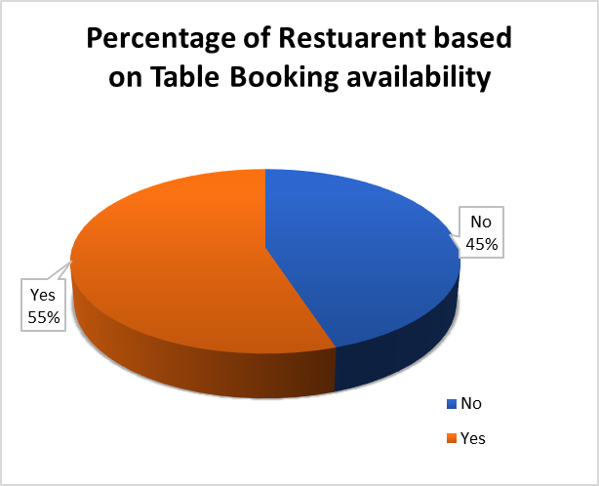

2. Percentage of Restuarent based on Online Delivery availability

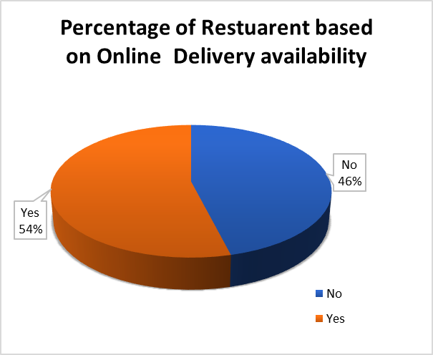

**Key Insights:**

**Higher Ratings for Table Booking:**

* Restaurants that offer table booking have an average rating of 3.50, whereas those without it have 2.85.
* This suggests that customers prefer restaurants with table booking, likely due to better service, convenience, or a structured dining experience.

**Higher Ratings for Online Delivery:**

* Restaurants with online delivery have an average rating of 3.29, compared to 2.81 for those that do not.
* This indicates that providing online delivery enhances customer satisfaction, possibly due to accessibility and convenience.

**Overall Impact on Ratings:**

* The overall average rating across all restaurants is 2.94.
* Both table booking and online delivery contribute positively to ratings, with table booking showing a stronger impact.

#### **Recommendations:**

**Implement Table Booking for Higher Customer Satisfaction:**

* Since table booking leads to significantly higher ratings, restaurants should adopt or improve their reservation systems to enhance customer experience.

**Expand Online Delivery Services:**

* While online delivery also improves ratings, its impact is slightly lower than table booking.
* Investing in efficient delivery services, packaging, and timely deliveries can further improve customer ratings.

**Analyze Customer Feedback for Further Improvements:**

* Conduct surveys or analyze customer reviews to understand why table booking has a stronger impact on satisfaction.
* Optimize both dine-in and online experiences based on these insights.

1. **Should the team keep the rate of cuisines higher? Will that affect the feedback? According to our data are the rates of cuisines and ratings, correlated?**Average of Average_Cost_for_two vs. Average of Rating  
   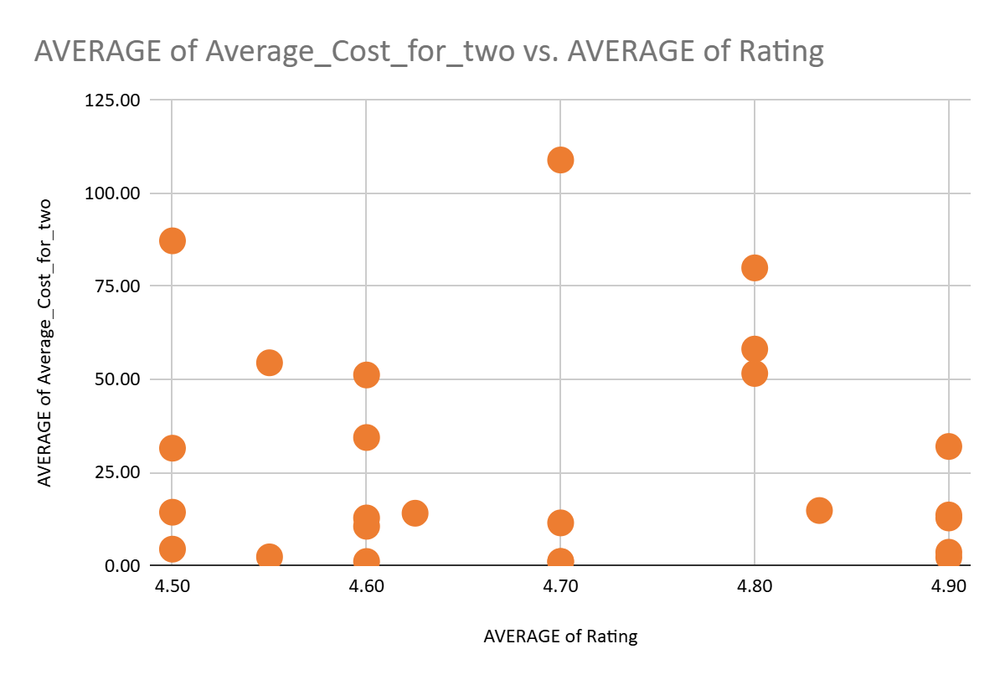

### **Key Insights:**

* **Weak correlation (0.238) between price and ratings** – This suggests that pricing is not the primary driver of customer satisfaction.
* **Some high-cost cuisines have high ratings** (e.g., European, Asian, Indian – 36,202.52 with 4.9 rating), but many lower-cost options also have good ratings.
* **Certain budget-friendly options also have high ratings** (e.g., Desserts – 1,228 with 4.8 rating), showing that affordability can still attract positive feedback.
* **Diverse cuisines tend to have mixed ratings** – Some multi-cuisine combinations like American, Chinese, North Indian (564.40, 2.5 rating) performed poorly, suggesting that trying to cater to too many tastes may lower satisfaction.
* **Niche cuisines often receive higher ratings** – Categories like Japanese, Sushi (9,050.63, 4.9 rating) and French, Japanese, Desserts (6,637.13, 4.8 rating) indicate that focused offerings may be better received.

### **Recommendations:**

* Do not raise prices without improving quality – Since price alone does not strongly influence ratings, an increase should be paired with better service, ambiance, and food quality.
* Focus on high-rated, affordable cuisines – Expand offerings in categories like Desserts (1,228, 4.8 rating) and Cafe (958.37, 4.31 rating) that maintain quality while being budget-friendly.
* Avoid overly broad cuisine combinations – Some multi-cuisine options have lower ratings; instead, focus on specialized menus that align with customer preferences.

1. **What is the distribution of the number of restaurants of different price ranges in all the countries?**

| **Count of RestaurantID** | **Price Range** |  |  |  |  |
| --- | --- | --- | --- | --- | --- |
| **Country** | **4** | **3** | **2** | **1** | **Grand Total** |
| **India** | **372** | **1061** | **2706** | **4008** | **8147** |
| **United States of America** | **23** | **110** | **165** | **136** | **434** |
| **United Kingdom** | **16** | **32** | **28** | **4** | **80** |
| **United Arab Emirates** | **22** | **29** | **9** |  | **60** |
| **South Africa** | **39** | **17** | **4** |  | **60** |
| **Brazil** | **35** | **16** | **7** | **2** | **60** |
| **New Zealand** | **16** | **16** | **4** | **3** | **39** |
| **Turkey** | **5** | **18** | **11** |  | **34** |
| **Australia** | **1** | **5** | **14** | **4** | **24** |
| **Philippines** | **9** | **12** | **1** |  | **22** |
| **Singapore** | **14** | **5** | **1** |  | **20** |
| **Indonesia** |  | **19** | **1** |  | **20** |
| **Qatar** | **14** | **5** | **1** |  | **20** |
| **Sri Lanka** | **3** | **10** | **6** |  | **19** |
| **Canada** | **1** |  | **3** |  | **4** |
| **Grand Total** | **570** | **1355** | **2961** | **4157** | **9043** |

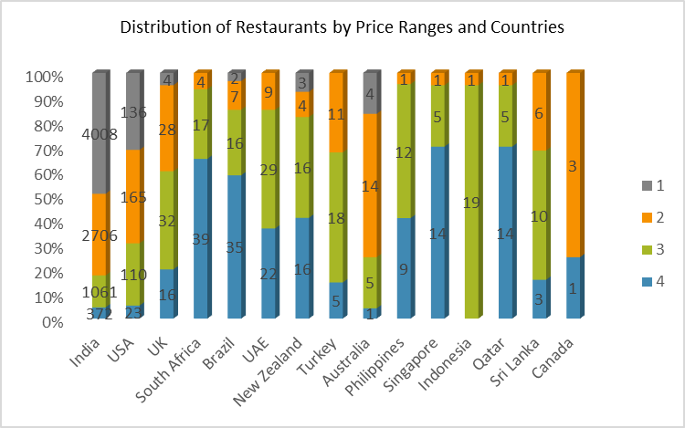

**India:** Leading with 8,156 restaurants (highest globally), dominated by low-cost dining (49%).

**United States:** 434 restaurants with a balanced price distribution, slightly favoring mid-range (38%).

**High-End Markets:** South Africa (39), Brazil (35), Qatar & Singapore (14 each) lead in luxury dining.

**Mid-Range Growth:** Thriving in the UK (32) and Turkey (18).

**Low-Cost Popularity:** India (4,009) and the U.S. (136) show strong demand for affordable dining.

**Recommendations:**

* Focus on low-cost options in India and the U.S..
* Expand mid-range offerings in the U.S. and United Kingdom.
* Target high-end markets in South Africa, Brazil, and Qatar/Singapore.

1. **Explain your approach in brief for suggesting countries/cities in order to open new restaurants, if the objective and subjective questions would have not been given to assist you. [you have to give bullet pointers in order to answer this question]**

Approach for Selecting Countries/Cities to Open New Restaurants :

**Data Cleaning & Preprocessing**

* Remove duplicates and handle missing values.
* Standardize country and city names for consistency.

**Identifying High-Demand Locations**

* Aggregate restaurant count per country and city.
* Analyze cities with high restaurant density and compare to demand indicators (votes, ratings).

**Customer Preferences & Popularity Analysis**

* Identify cuisines with high average ratings and votes.
* Evaluate price range preferences based on average cost for two.

**Competition & Market Saturation**

* Compare the number of restaurants per city with customer demand (ratings, votes).
* Find underpenetrated cities with fewer restaurants but high demand.

**Online Delivery & Table Booking Trends**

* Analyze the adoption of online delivery and table booking in different cities.
* Prioritize locations where these services are trending.

**Profitability & Cost Considerations**

* Compare average cost for two and price range with local currency value.
* Assess affordability and profitability of new openings.

**Final Location Selection**

* Shortlist cities based on demand, competition, and profitability.

**DASHBOARD**

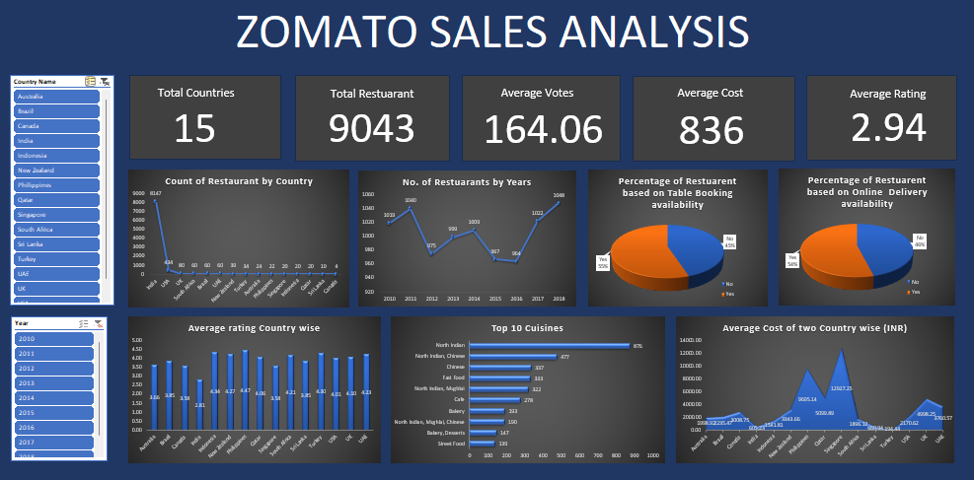

**SUMMARY**

**1. Selecting Countries for Expansion**

Prioritize Philippines, Indonesia, Turkey, New Zealand, and Sri Lanka due to low competition and high ratings.

Philippines & Indonesia offer the best opportunities with high customer satisfaction.

**2. Ideal Cities for Expansion**

Indonesia – Jakarta, Tangerang

New Zealand – Auckland, Wellington

Philippines – Quezon City, Makati City

Sri Lanka – Colombo

Turkey – Ankara, Istanbul

**3. Competitive Landscape**

Top Competitors (4.5+ ratings) – Silantro Fil-Mex (Philippines), Sushi Masa (Indonesia), Milse (New Zealand).

Low-Rated Restaurants (1-3 ratings) – De Fontein Belgian Beer Cafe, Elite Indian Restaurant (New Zealand).

**4. Cuisines to Focus On**

Highest Rated – World Cuisine, Sushi, Japanese, Seafood, Bar Food (4.90).

Strong Potential – Desserts, Filipino, Mexican, French.

Impact on Ratings – Higher ratings are linked to cuisine quality, not price.

**5. Online Delivery & Table Booking**

Both services increase ratings (3.60 vs. 2.73 without).

Table booking has the strongest positive impact.

Recommendation – Implement both for maximum satisfaction.

**6. Pricing Strategy**

No correlation between price and ratings (-0.07).

Focus on quality over price hikes.

Affordable cuisines (World Cuisine, Bar Food) offer high ratings at low cost.

**7. Restaurant Distribution by Price Range**

Low-cost restaurants dominate in India & the U.S.

Mid-range restaurants thrive in the U.S. & UK.

High-end restaurants concentrated in South Africa, Brazil, and Qatar/Singapore.

**8. Expansion Recommendations**

Target low-cost markets in India & U.S.

Expand mid-range restaurants in U.S. & UK.

Develop high-end restaurants in South Africa, Brazil, Qatar, Singapore.

|  | | | | | | | | | | | | | | | | | | | | |
| --- | --- | --- | --- | --- | --- | --- | --- | --- | --- | --- | --- | --- | --- | --- | --- | --- | --- | --- | --- | --- |
|
|
|
|
|
|
|
|
|
|
|
|
|
|
|
|
|
|
|
|
|
|
|
|
|
|
|
|
|
|
|
|
|
|
|
|
|
|
|
|
|
|
|
|
|
|
|
|
|
|
|
|
|
|
|
|
|
|
|
|
|
|
|
|
|
|
|
|
|